dcs_logo.eps

# **Environmental Policy**

Dedman Contract Services Limited is committed to prevent pollution so far as is reasonably practicable in all business activities associated with the products and services we provide our customers.

We have identified our significant environmental aspects which provide a framework for establishing and reviewing the Company Environmental Objectives and Targets. We are committed to Continuously Improve our Environmental Efficiency and are committed to ensure complete compliance to applicable Legal requirements as well as other requirements pertinent to our specific Environmental Aspects. In particular, we will promote Environmental Best Practice to enable our clients to improve their own environmental performance.

In addition to this we will:

* manage and reduce our own environmental aspects and impacts,
* undertake regular reviews of our operations, measure and maintain our existing environmental performance and where possible make improvements,
* undertake environmental risk assessments in order to identify significant environmental aspects and impacts,
* provide technically competent services and professional solutions that help to conserve and protect the environment,
* raise environmental awareness with our staff, suppliers, subcontractors, clients, end users, and those other organisations with whom we have contact,
* consider sustainable criteria, end of life associated with plant and equipment and encourage the use of sustainable resources, designs and practices over the whole life cycle of the products and services we provide.

We are serious about the policies we have declared. These have been established and agreed and endorsed by the Directors of the business. We have documented and implemented an integrated Business Management System, compliant with the requirements of BS EN ISO 9001:2015 and BS EN ISO 14001:2015.

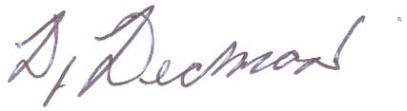

Derrick Dedman

Managing Director

12th October 2017